

**CAPSTONE PROJECT I**

CMU-SE 450

**USER INTERFACE**

Version 1.0

Date: March 8th, 2021

**DTU Simulated Digital Map**

**Submitted by**

**Phuoc, Huynh Van**

**Tu, Thi Vo**

**Duan, Mai Le**

**Tuan, Huynh Van**

**Approved by**

**Trang, Nguyen Thi Bao M.Sc.**

Proposal Review Panel Representative:

Name Signature Date

Capstone Project 1- Mentor:

Name Signature Date

|  |  |  |  |  |
| --- | --- | --- | --- | --- |
| **PROJECT INFORMATION** | | | | |
| **Project acronym** | SDM | | | |
| **Project title** | DTU Simulated Digital Map | | | |
| **Start date** | September 6th, 2021 | **End Date** | September 10th, 2021 | |
| **Lead institution** | International School, Duy Tan University | | | |
| **Project mentor** | Trang, Nguyen Thi Bao M. Sc  Email: nguyenthibaotrang@gmail.com  Phone: 0915 774 711 | | | |
| **Product owner & Contact Detail** | Trang, Nguyen Thi Bao M. Sc  Email: nguyenthibaotrang@gmail.com  Phone: 0915 774 711 | | | |
| **Partner organization** | Duy Tan University | | | |
| **Scrum Master** | Phuoc, Huynh Van | huynhphvan@gmail.com | | 0765 386 683 |
| **24211206251** | Phuoc, Huynh Van | huynhphvan@gmail.com | | 0765 386 683 |
| **24211204940** | Duan, Mai Le | maileduan24899@gmail.com | | 0385 338 303 |
| **24201216454** | Tu, Vo Thi | vothitu1001@gmail.com | | 0359 241 015 |
| **24211214338** | Tuan, Huynh Van | hvantuan0407@gmail.com | | 0898 199 447 |

|  |  |  |  |
| --- | --- | --- | --- |
| **USER INTERFACE DOCUMENT** | | | |
| **Document Title** | User Interface Document | | |
| **Author(s)** | C1SE.03 Team | | |
| **Role** |  | | |
| **Date** | March 8th, 2021 | **File name:** | [SDM]UserInterface_ver1.0 |
| **URL** |  | | |
| **Access** | Project and CMU Program | | |

|  |  |  |  |
| --- | --- | --- | --- |
| **REVISION HISTORY** | | | |
| **Version** | **Person(s)** | **Date** | **Description** |
| **1.0** | All members | March 8th, 2021 | Create Document |

|  |  |  |  |
| --- | --- | --- | --- |
| **SIGNATURE**  **Document Approvals:** The following signatures are required for approval of this document. | | | |
| **Mentor & Product owner** | Trang, Nguyen Thi Bao M. Sc | **Signature:** |  |
| **Date:** |  |
| **Scrum master** | Phuoc, Huynh Van | **Signature:** |  |
| **Date:** |  |
| **Team member(s)** | Tuan, Huynh Van | **Signature:** |  |
| **Date:** |  |
| Duan, Mai Le | **Signature:** |  |
| **Date:** |  |
| Tu, Vo Thi | **Signature:** |  |
| **Date:** |  |

**Contents**

1. Introduction 6

1.1. Purpose 6

1.2. Scope 6

1.3. List of User Interface for Sprint 6

2. Describe User Interface for Admin 7

2.1. UI-01: Login 7

2.2. UI-02: Logout 8

2.3. UI-03: Add criminal record 8

2.4. UI-04: Update criminal record 11

2.5. UI-05: Delete criminal record 14

3. Describe User Interface for User 15

3.1. UI-06: Welcome page 15

3.2. UI-07: Application information 16

3.3. UI-08: Product Experience Page 17

3.4. UI-10: Determine face from the image and information 18

3.5. UI-11: Determine information and show similar faces 18

3.6. UI-12: Point out the difference in the face which changes 19

# **Introduction**

## **Purpose**

* This document describes the design interface of “Facial Identification Matching Web Application” System.

## **Scope**

* Overview of the stages and modules of the software.
* Create complete interfaces, and describe them clearly.

## **List of User Interface for Sprint**

|  |  |  |  |  |
| --- | --- | --- | --- | --- |
| **Roles** | **User Interface ID** | **UI Name** | **Description** | **Notes** |
| Admin | UI-01 | Login | This form is used for the admin to login into the system. |  |
| Admin | UI-02 | Logout | This form is used for the admin to log out of the system. |  |
| Admin | UI-04 | Add geojson’s maps record | This form is used for the admin to add geojson’s maps record into the database. |  |
| Admin | UI-05 | Update geojson’s maps record | This form is used for the admin to update geojson’s maps record in the database. |  |
| Admin | UI-06 | Delete geojson’s maps record | This form is used for the admin to delete geojson’s maps record in the database. |  |
| Admin | UI-07 | View list of users | This form is used for the admin to view all of the users. |  |
| Admin | UI-08 | View user’s detail | This form is used for the admin to view detail of the user. |  |
| Admin | UI-09 | Reset user’s password | This form is used for the admin to reset password of the users. |  |
| Admin | UI-10 | Delete user account | This form is used for the admin to delete the account of the users. |  |
| Admin | UI-11 | Add VR360 images | This form is used for the admin to add VR360 images into the database. |  |
| Admin | UI-12 | Update VR360 images | This form is used for the admin to update VR360 images in the database. |  |
| Admin | UI-13 | Delete VR360 images | This form is used for the admin to delete VR360 images in the database. |  |
| User | UI-14 | Application information | This page is used for the user to see the welcome screen. |  |
| User | UI-15 | User Guide | This form is used for the user to  see the application information. |  |
| User | UI-16 | Register | This form is used for the user to register an account. |  |
| User | UI-17 | Login | This form is used for the user to login into the app. |  |
| User | UI-18 | Logout | This form is used for the user to log out of the app. |  |
| User | UI-19 | Forgot password | The form is used to get the password of the user. |  |
| User | UI-20 | Home | This form is used for the user to view the home screen. |  |
| User | UI-21 | Maps |  |  |
| User | UI-22 | Find facility |  |  |
| User | UI-23 | Find building |  |  |
| User | UI-24 | Find classroom |  |  |
| User | UI-25 | Show directions |  |  |
| User | UI-26 | Add friends |  |  |
| User | UI-27 | View friend’s profile |  |  |
| User | UI-28 | Show location |  |  |
| User | UI-29 | Watch 360 view of building |  |  |
| User | UI-30 | Watch 360 view of classroom |  |  |
| User | UI-31 | Update profile |  |  |
| User | UI-32 | Change password |  |  |

1. **Describe User Interface for Admin**

## **UI-01: Login**





|  |  |  |  |  |  |
| --- | --- | --- | --- | --- | --- |
| **From** | **Condition** | **Null** | **Control Type** | **Target** | **Notes** |
| 1 | Input |  | Textbox | Input email |  |
| 2 | Input |  | Textbox | Input password |  |
| 3 | Click |  | Button | Click to login into the system |  |

## **UI-02: Logout**

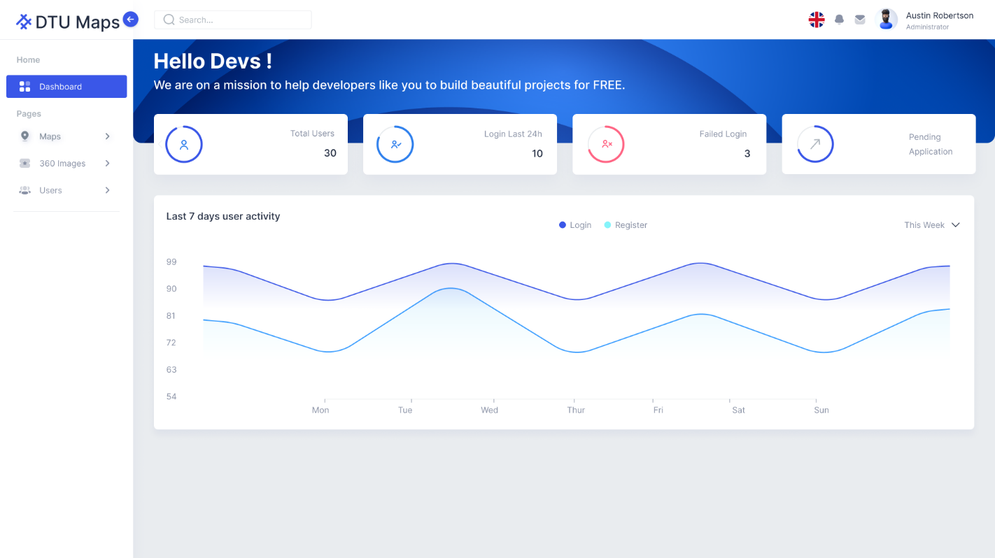

|  |  |  |  |  |  |
| --- | --- | --- | --- | --- | --- |
| **Form** | **Condition** | **Null** | **Control Type** | **Target** | **Notes** |
| 1 | Click |  | Button | Click to log out of the system |  |

* 1. **UI-03: Add geojson’s maps record**

|  |  |  |  |  |  |
| --- | --- | --- | --- | --- | --- |
| **Form** | **Condition** | **Null** | **Control Type** | **Target** | **Notes** |
| 1 | Click |  | Button | Click to add the criminal |  |
| 2 | Input |  | Textbox | Input the information into each field of the General Information table (if any). |  |
| 3 | Click |  | Image | Click to upload image |  |
| 4 | Click |  | Button | Click to display Guilty table |  |
| 5 | Input |  | Textbox | Input the information into each field of the Guilty table (if any). |  |
| 6 | Click |  | Button | Click to come back the General Table |  |
| 7 | Click |  | Button | Click to confirm the entered data |  |
| 8 | View |  | Form | Display successful add message |  |

* 1. **UI-04: Update geojson’s maps record**

|  |  |  |  |  |  |
| --- | --- | --- | --- | --- | --- |
| **Form** | **Condition** | **Null** | **Control Type** | **Target** | **Notes** |
| 1 | Click |  | Button | Click to update information |  |
| 2 | Input |  | Textbox | Input the information in the field to be updated on the General Information table (if needed). |  |
| 3 | Click |  | Image | Click to update the criminals’ image (if needed) |  |
| 4 | Click |  | Button | Click to display Guilty table |  |
| 5 | Input |  | Textbox | Input the information in the field to be updated on the Guilty table (if needed). |  |
| 6 | Click |  | Button | Click to come back the General Table |  |
| 7 | Click |  | Button | Click to confirm the entered data |  |
| 8 | View |  | Form | Display successful update message |  |

* 1. **UI-05: Delete geojson’s maps record**

|  |  |  |  |  |  |
| --- | --- | --- | --- | --- | --- |
| **Form** | **Condition** | **Null** | **Control Type** | **Target** | **Notes** |
| 1 | Click |  | Button | Click to choose delete function |  |
| 2 | Click |  | Button | Click to delete criminal case |  |
| 3 | Click |  | Alert | Click “Yes” to delete, “No” to cancel |  |

1. **Describe User Interface for User**
   1. **UI-06: Application information**

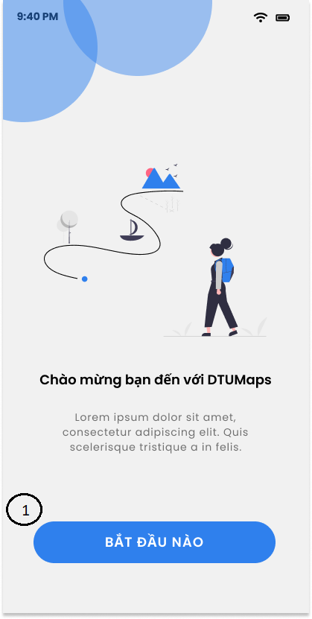

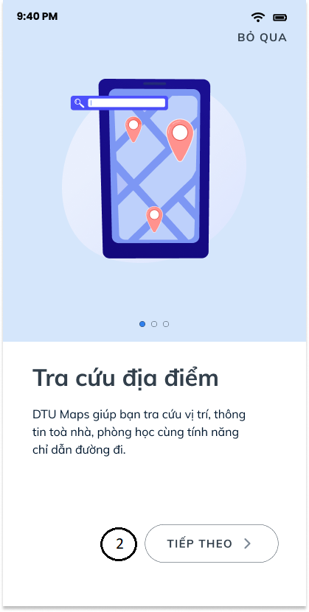

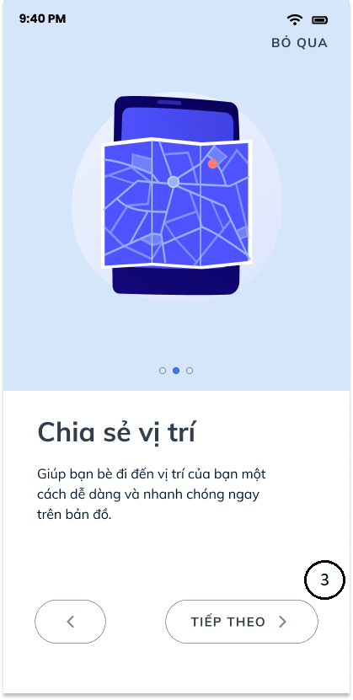

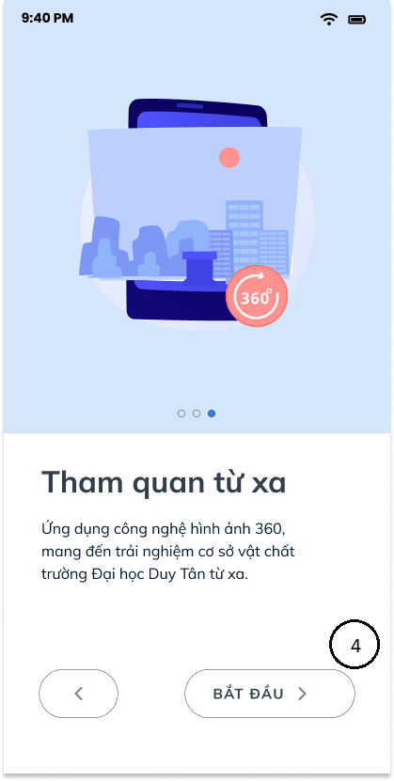

|  |  |  |  |  |  |
| --- | --- | --- | --- | --- | --- |
| **Form** | **Condition** | **Null** | **Control Type** | **Target** | **Notes** |
| 1 | Click |  | Button | Click to the welcome page |  |
| 2 | Click |  | Button | Click to the benefit page |  |
| 3 | Click |  | Button | Click to the about us page |  |
| 4 | Click |  | Button | Click to the product experience page |  |

* 1. **UI-07: User Guide**

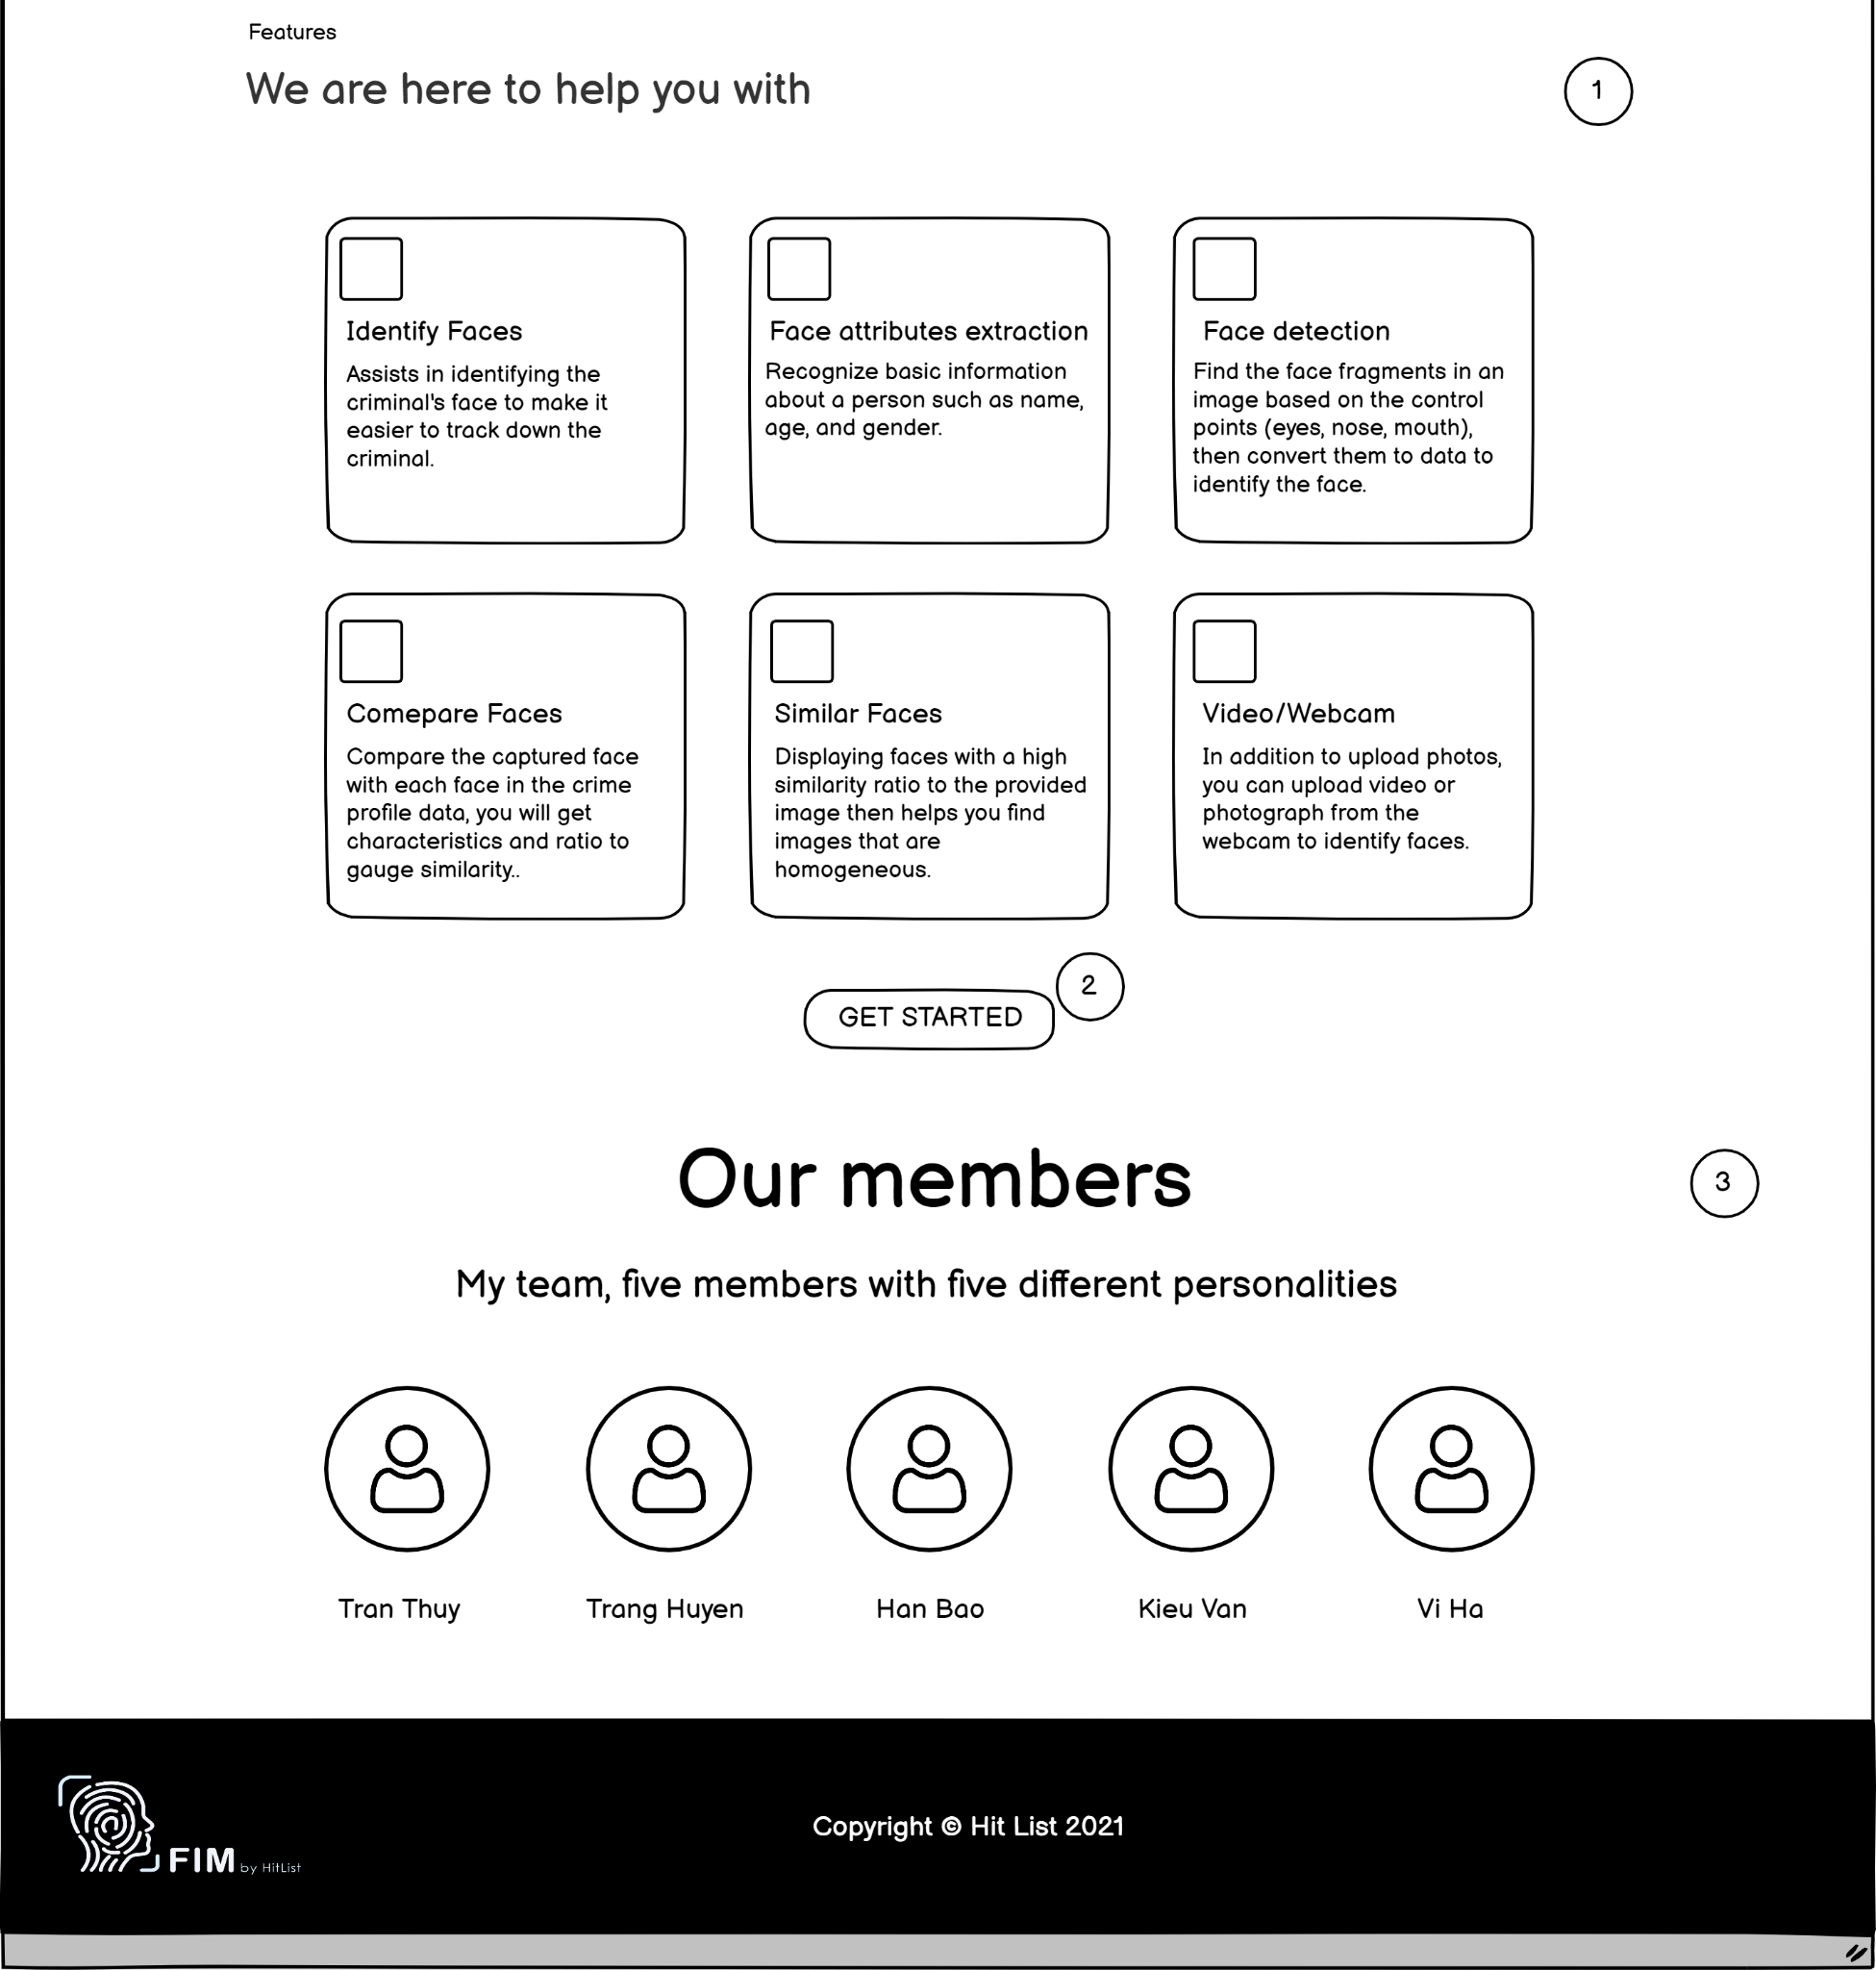

|  |  |  |  |  |  |
| --- | --- | --- | --- | --- | --- |
| **From** | **Condition** | **Null** | **Control Type** | **Target** | **Notes** |
| 1 | View |  | Page | Display the application information |  |
| 2 | Click |  | Button | Click to the product experience page |  |
| 3 | View |  | Page | Display the information of team |  |

* 1. **UI-08: Register**

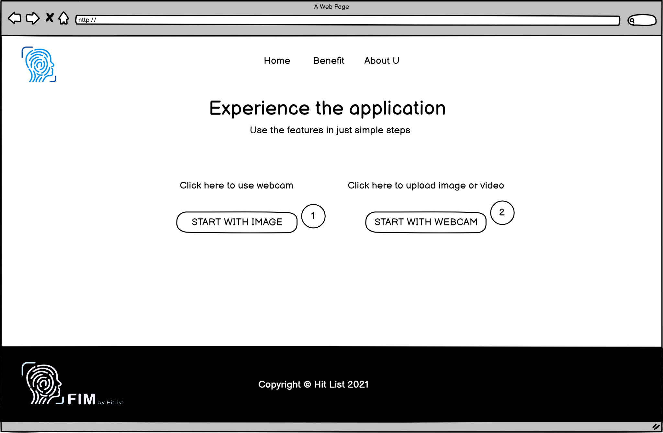

|  |  |  |  |  |  |
| --- | --- | --- | --- | --- | --- |
| **From** | **Condition** | **Null** | **Control Type** | **Target** | **Notes** |
| 1 | Click |  | Button | Click to choose the photo or video from the folder |  |
| 2 | Click |  | Button | Click to the webcam |  |

* 1. **UI-10: Login**

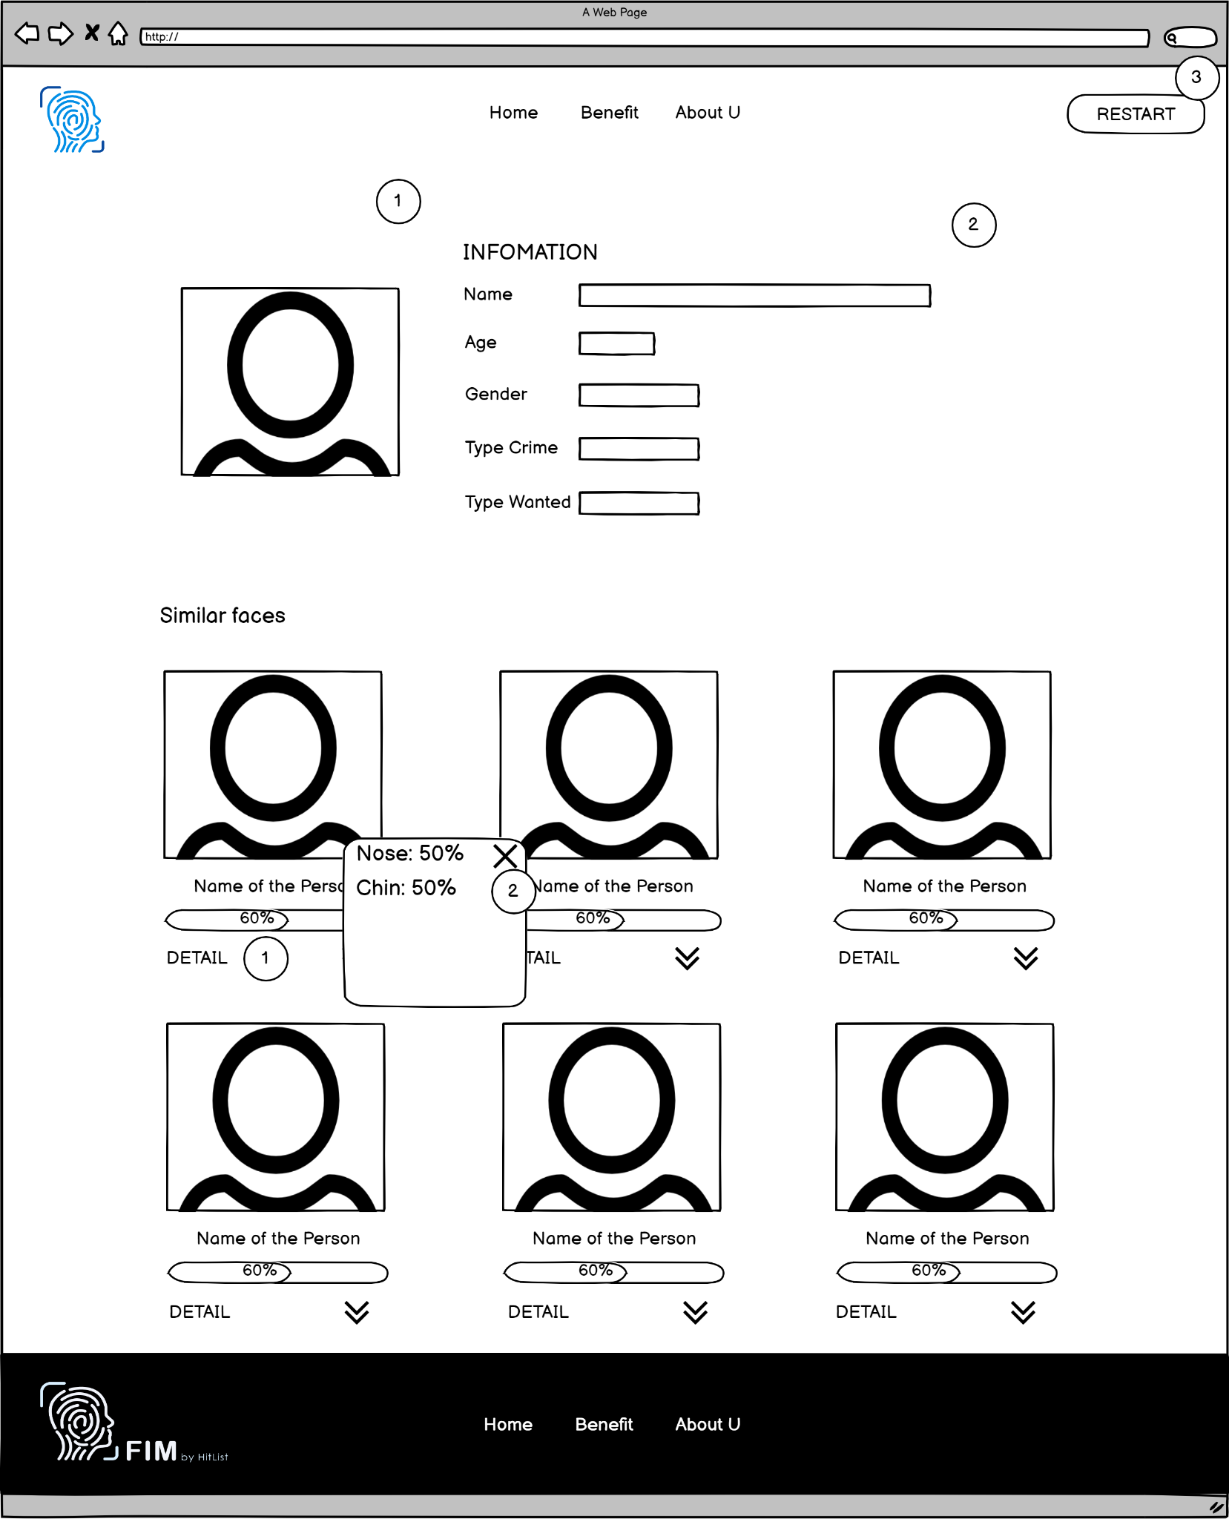

|  |  |  |  |  |  |
| --- | --- | --- | --- | --- | --- |
| **From** | **Condition** | **Null** | **Control Type** | **Target** | **Notes** |
| 1 | View |  | Image | Displays the image extracted |  |
| 2 | View |  | Section | Show the name, age, the gender of a person's |  |
| 3 | Click |  | Button | Click to restart with image or webcam |  |

* 1. **UI-11: Logout**

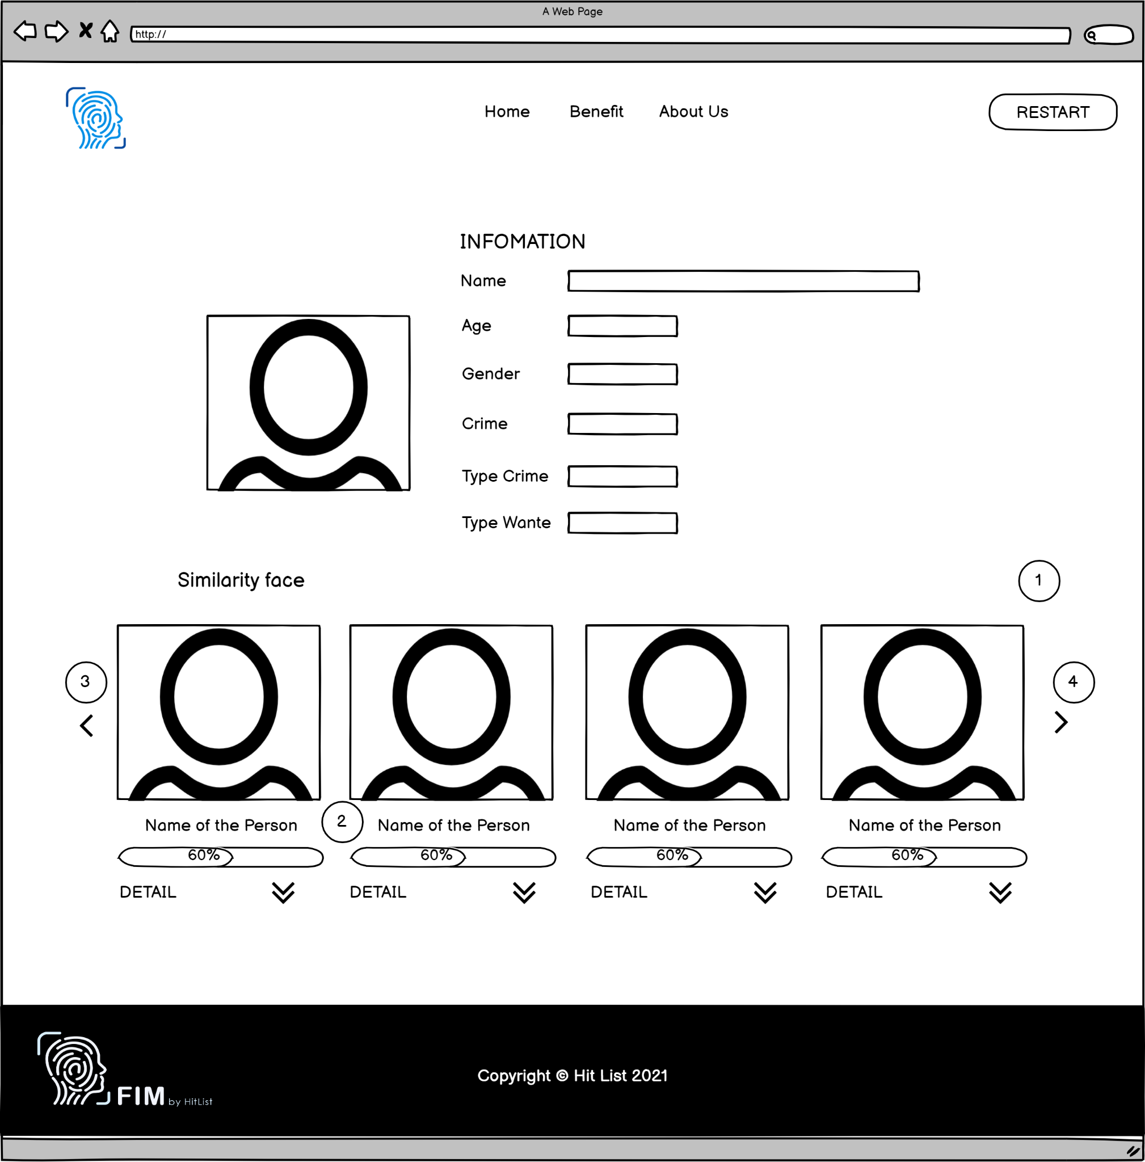

|  |  |  |  |  |  |
| --- | --- | --- | --- | --- | --- |
| **From** | **Condition** | **Null** | **Control Type** | **Target** | **Notes** |
| 1 | View |  | Image | Display all of the highly similar faces |  |
| 2 | View |  | Progress bar | Show how many similarities between faces. |  |
| 3 | Click |  | Button | Display previous similar faces |  |
| 4 | Click |  | Button | Display next similar faces |  |

* 1. **UI-12: Point out the difference in the face which changes**

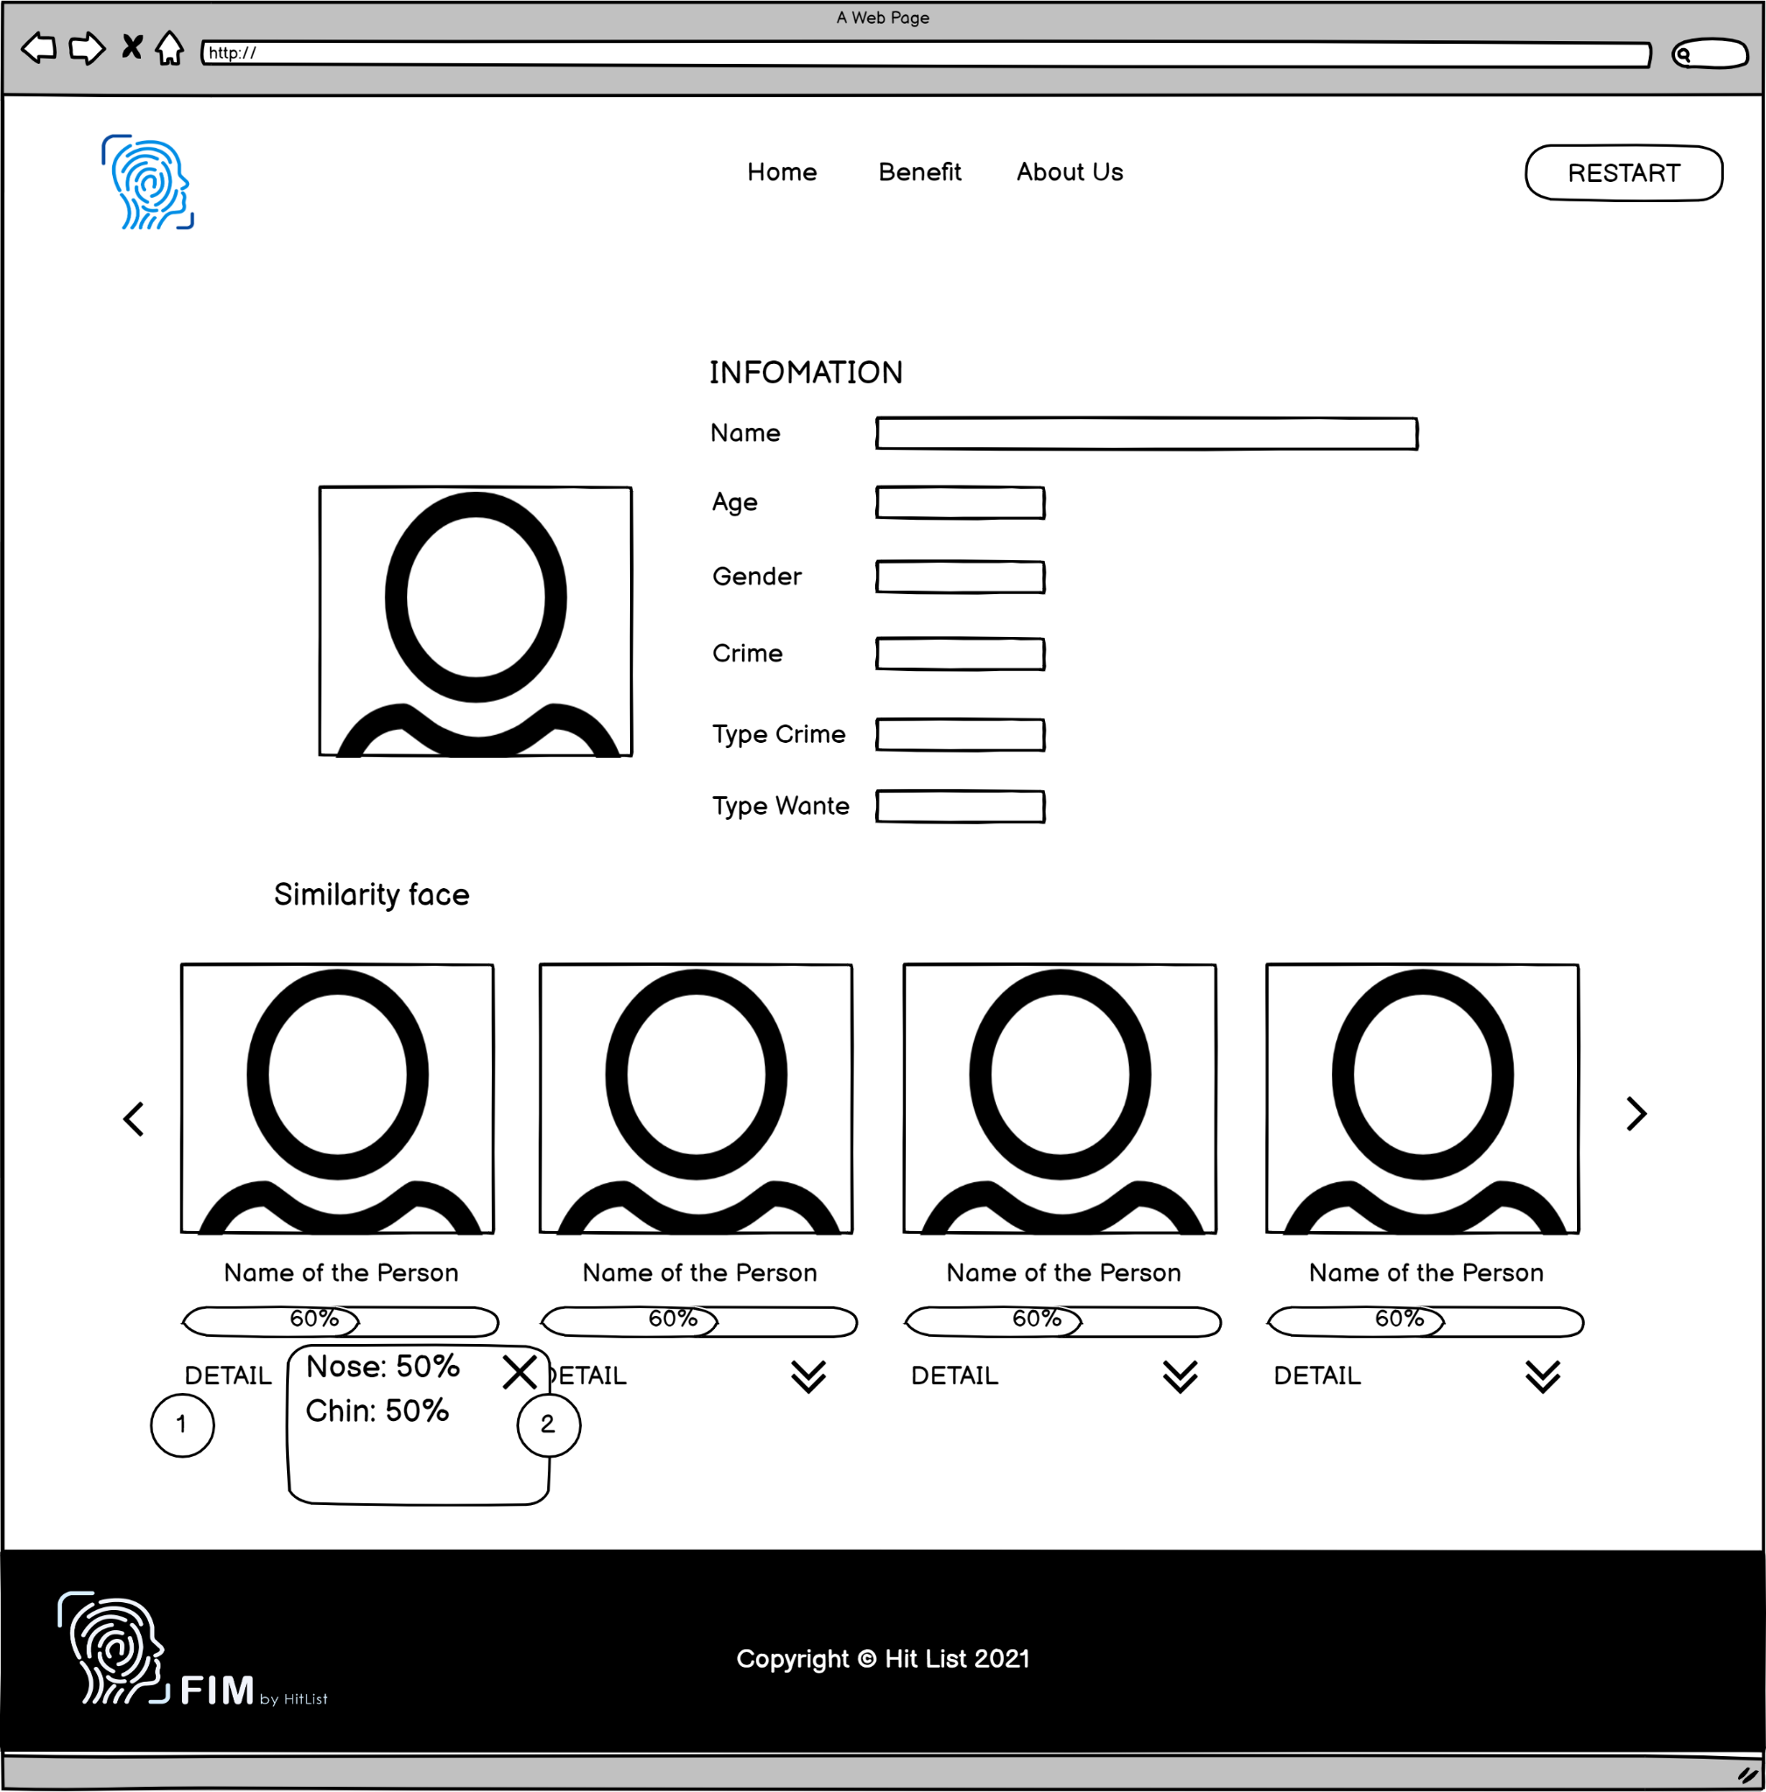

|  |  |  |  |  |  |
| --- | --- | --- | --- | --- | --- |
| **From** | **Condition** | **Null** | **Control Type** | **Target** | **Notes** |
| 1 | View |  | Detail | Show the difference in the face which changes |  |
| 2 | Click |  | Button | Click to hide the differences table |  |